The ELM Network ACTION group
~calling for interested people to join~

The ELM Network is a suicide prevention and awareness group based in the Mount Alexander Shire, established in late 2016. We aim to:
- Increase understanding and awareness in the community of suicide and suicide prevention;
- Increase the community’s capacity to support themselves and each other; and
- Provide support to people bereaved by suicide.

We are currently looking for skilled, passionate people to join our ACTION groups and help us progress our action plan for 2018. The action groups are outlined below and spots are available on groups at different times, as outlined on our website https://www.cch.org.au/elm/get-involved/.

We currently have six action groups and are looking for a limited number of people to join each one. They are:
- Finance & Fundraising
- Advocacy & Education
- Communications & Marketing
- Evidence(including service mapping and evaluation)
- Events
- Peer Support (community members bereaved by suicide who are trained to provide peer support to other people bereaved by suicide)

If you would like to get involved please fill out the details below and return to theelmnetwork@gmail.com.

Name:

Email:

Phone number:

Connection to Mount Alexander:

Action groups generally meet once a month, but frequency of meetings will be determined by the current workload of the group. There will also be tasks for all action group members to complete in between meetings. Are you able to meet this time commitment?

Yes / No

We are looking for members to make a minimum commitment to their chosen action group of 12 months, although we do realise that life is dynamic and fluid and things can ‘come up’ (family emergencies, work commitments, travel etc). Are you able to make this commitment?

Yes / No

Do you already have, or are you willing to get, a current Working with Children Check and police check if your application is successful? (ELM will cover costs associated with police checks)

I have already / I don’t have but am willing to get / I don’t have and am not willing to get

Please rank you preferred action group to participate from most preferred (1) to least preferred (6). Only put a number next to groups you’re interested in joining, although we will only allocate people to one action group. If you would like more information on any of the action groups please contact theelmnetwork@gmail.com.

- Finance & fundraising
- Advocacy & Education
- Communications & Marketing
- Evidence
- Events
- Peer Support

What skills and qualities do you think you will bring to your preferred action group/s?

How did you hear about this opportunity?

Other comments:

Thank you for taking the time to fill this in. Someone from The ELM Network will be in touch soon.
The ELM Network Membership Tree
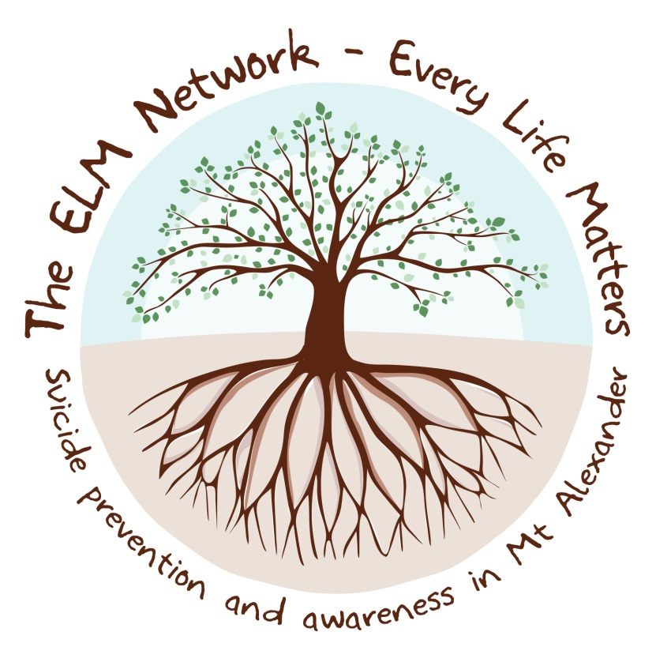
Core group |  | ACTION GROUPS |  | Friends of ELM
The core group meets once a month and is responsible for the overall direction and governance of ELM. Core group members must also sit on at least one action group. |  | Action groups generally meet once a month to work on one each of the following areas:  - Peer Support  - Communications & Marketing  - Events  - Advocacy & Education  - Finance & Fundraising  - Mapping and Evaluation |  | Friends of ELM receive regular updates through Facebook and email newsletters. They are encouraged to share and promote the work of ELM and might get involved with one off volunteering for activities and events without an ongoing commitment.
Maximum 12 people |  | Maximum 12 people per action group |  | As many people as would like to be involved!
New members can join once per year if spaces are available. Nominations open in July. |  | New members can join any time throughout the year if spaces are available. |  | New friends can get on board at any time throughout the year.

For more information contact the ELM Network via Facebook @theELMnetwork
or email on theelmnetwork@gmail.com

